Matlab exercise 2 for SC40025 Filtering and Control by Niels Uitterdijk
December 2017. This script uses two functions that transform
input/output data to either a state space system or an ARX system.

3.1 Check which sets are useful
The UosN matrix of dataset 0, 1 and 4 are full rank. As by definition 10.1 these are the useful datasets.

3.2 How should the model order n and the parameter s should be chosen?
It is obvious that the order of system s should be taken large enough to have a state space representation of the data. Also, s defines the length of one sequence or column size of the Hankel matrices. N represents the amount of columns in the Hankel matrices and it is necessary to have n < s << N. Here n is the order of the actual system, s the order of the identified system and N the amount of columns used to get the identified system.

3.3 Why is it useful to have the singular values of YP as output of mysubid
With the singular values you can check the order of the system and therefor see if you've chosen s,n and N wisely.

3.4 Use both your functions to identify a 6th order model of the system for the two suitable sets of data
[Aest1 Best1] = myarx(y1,u1,6);
[Aest4 Best4] = myarx(y4,u4,6);
[At1 Bt1 Ct1 Dt1 x0t1 S1] = mysubid(y1,u1,12,6);
[At4 Bt4 Ct4 Dt4 x0t4 S4] = mysubid(y4,u4,12,6);

3.5 Compare the bode plots to the real tfse
sys1si = ss(At1,Bt1,Ct1,Dt1,-1);
sys4si = ss(At4,Bt4,Ct4,Dt4,-1);
sys1arx = tf(Best1',Aest4',-1);
sys4arx = tf(Best4',Aest4',-1);
subplot(1,2,1)
bode(tfse)
hold on
bode(sys1si)
bode(sys1arx)
legend('Original system','Subspace Identification','ARX')
subplot(1,2,2)
bode(tfse)
hold on
bode(sys4si)
bode(sys4arx)
legend('Original system','Subspace Identification','ARX')
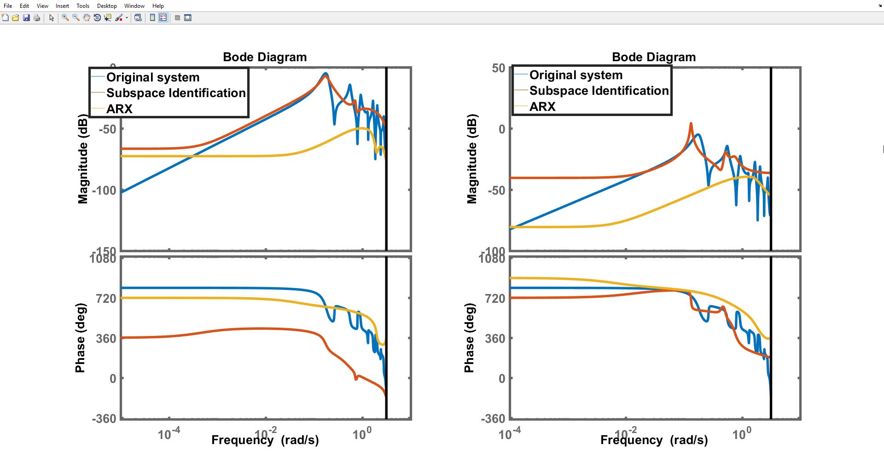

4.1 Estimate the order of the system
The order of the system can be estimated by looking at the singular values of the SVD. The order of dataset0 turns out to be 2.
[At0 Bt0 Ct0 Dt0 x0t0 S0] = mysubid(y0,u0,25,6);

4.2 Biase dataset 0 and recheck the order of the system.
By switching the data the rank of the system has become 3. Somehow an additional state is necessary to achieve the behaviour of y.
y00 = y0 + 0.2;
[At00 Bt00 Ct00 Dt00 x0t00 S00] = mysubid(y00,u0,25,3);

4.3 Is the 00 system reachable and where are its poles?
Getting the transferfuntion of the state space system gives the poles, which are located at 1,0.4414,0.1586. Checking the reachability with the reachability matrix confirms that the system is not reachable as it is not full rank.
sys = ss(At00,Bt00,Ct00,Dt00);
H = tf(sys);
p = pole(H);
Wt = [];
for n=1:6
Wt = [At00^(n-1)*Bt00 Wt];
end
Published with MATLAB® R2016b

1 My ARX script
function [At, Bt, Ct, Dt, x0t, S] = mysubid(y, u, s, n)

Structure Data
N = length(u) - s;
UosN = zeros(s,N);
for m = 1:s
for o = 1:N
UosN(m,o) = u(m+o);
YosN(m,o) = y(m+o);
end
end

RQ decomposition
[Q,R] = qr([UosN;YosN]');
Qt = Q'; Rt = R';

Getting R22
R22 = Rt(s+1:2*s,s+1:2*s);

SVD of R22
[Un,St,V] = svd(R22);

Calculating system matrices
Ct = Un(1,1:n);
At = pinv(Un(1:s-1,1:n))*Un(2:s,1:n);
[Bt Dt x0t] = subidhelp(y,u,At,Ct);

Rewriting the singular values to vector
for n=1:s
S(n) = St(n,n);
end
end

2. My subid script
function [aest, best] = myarx(y,u,N)

Structure data
Data is structured to create matrix Phi which is used to solve Y-theta*phi for minimal error. Theta is then splitted in the constants for a estimates and b estimates.
s = length(y);
teta = zeros(2*N,1);
phi = zeros(s,2*N);
for n=2:s
phi(n-1,1) = y(n-1);
phi(n,2:N) = phi(n-1,1:N-1);
phi(n-1,N+1) = u(n-1);
phi(n,N+2:2*N) = phi(n-1,N+1:2*N-1);
end
phi2 = phi(N+1:s,:);
y2 = y(N+1:s,:);

Solving for theta
teta_fm = pinv(phi2)*y2;
aest = teta_fm(1:N);
best = teta_fm(N+1:2*N);
end
Published with MATLAB® R2016b

